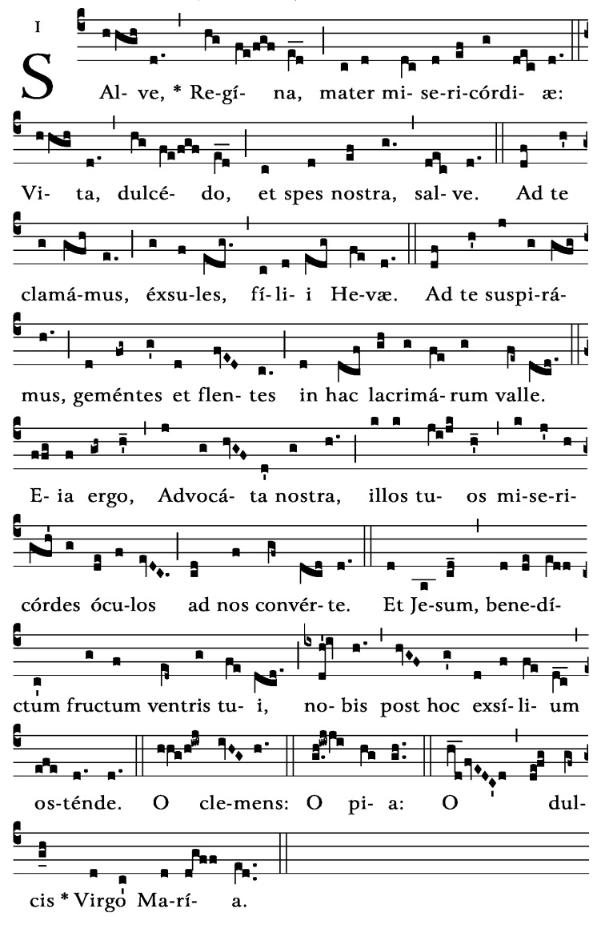

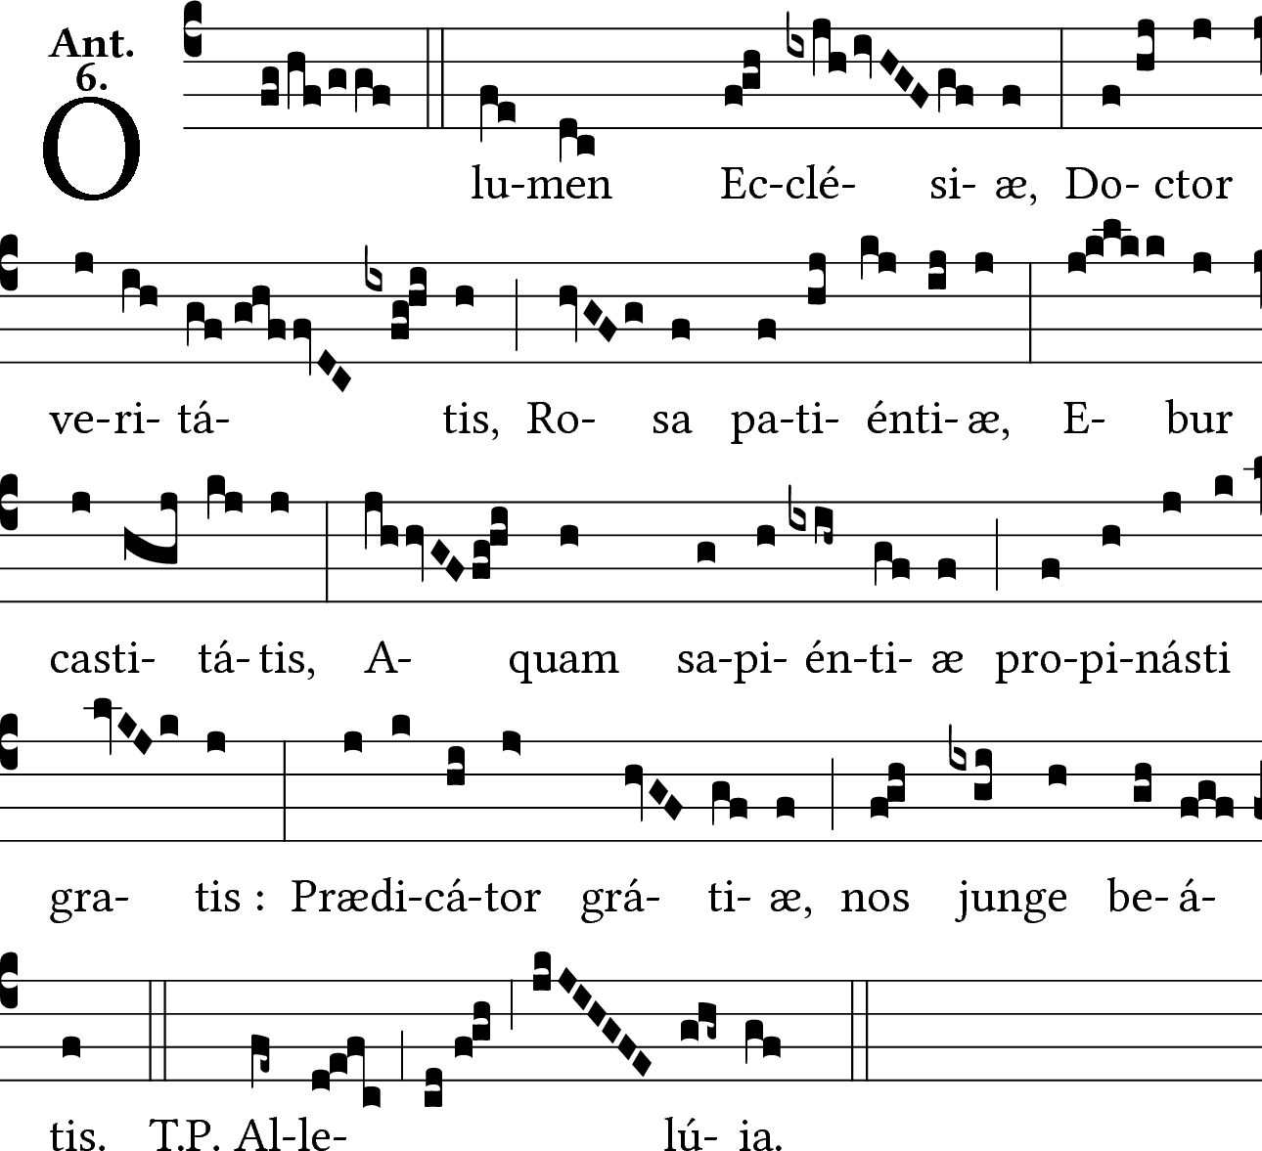

Friday Night Prayer
Compline

O Sacred Banquet
(In Presence of the Blessed Sacrament Only )

(All) O Sacred Banquet, in which Christ becomes our food, the memory of His passion is celebrated, the soul is filled with grace, and a pledge of future glory is given to us.
V. You gave them bread from heaven.
(All) R. Containing every blessing.
Let us pray:
(All) 0 God, in this wonderful Sacrament, You have left us a memorial of Your passion. Help us, we beg You, so to reverence the sacred mysteries of Your Body and Blood that we may constantly feel in our lives the effects of Your redemption. You who live and reign forever and ever. Amen

(If not in the Presence of the Blessed Sacrament start here)
(Leader) God, come to my assistance.
(All) Lord, make haste to help me.
(Leader) Glory to the Father, and to the Son, and to the Holy Spirit:
(All) as it was in the beginning, is now, and will be forever. Amen. (Alleluia.)

(Pause for Examination of Conscience)

(All) I confess to almighty God, to blessed Mary ever virgin, to blessed Dominic our father, to all the saints, and to you my brothers and sisters, that I have sinned exceedingly; by thought, word, deed and omission, through my fault: and I beseech you to pray for me.
(Leader) May Almighty God have Mercy on us, forgive us all our sins, and may He free us from all evil, keep us safe and strengthen us in every good work, and bring us to eternal life.
(All) Amen.

Hymn (All)

O Christ, you are the light and day
Which drives away the night,
The ever shining Sun of God
And pledge of future light.

As now the evening shadows fall
Please grant us, Lord, we pray,
A quiet night to rest in you,
Until the break of day.

Remember us, poor mortal men,
We humbly ask, 0 Lord,
And may your presence in our souls
Be now our great reward. Amen

PSALMODY

(Leader) Day and night I cry to you, my God. (or Alleluia, Alleluia, Alleluia)

PSALM 88
(Leader) Lord my God, I call for help by day;
(Leader & Side A) I cry at night before you.
(Side B) Let my prayer come into your presence. O turn your ear to my cry.

(Leader & A) For my soul is filled with evils;
My life is on the brink of the grave.
(B) I am reckoned as one in the tomb;
I have reached the end of my strength,

(Leader & A) Like one alone among the dead, like the slain lying in their graves,
(B) Like those you remember no more,
cut off, as they are, from your hand.

(Leader & A) You have laid me in the depths of the tomb,
in places that are dark, in the depths.
(B) Your anger weighs down upon me;
I am drowned beneath your waves.

(Leader & A) You have taken away my friends
and made me hateful in their sight.
(B) Imprisoned, I cannot escape;
my eyes are sunken with grief.

(Leader & A) I call to you, Lord, all the day long;
to you I stretch out my hands.
(B) Will you work your wonders for the dead? Will the shades stand and praise you?

(Leader & A) Will your love be told in the grave
or your faithfulness among the dead?
(B)Will your wonders be known in the dark or your justice in the land of oblivion?

(Leader & A) As for me, Lord, I call to you for help; in the morning my prayer comes before you
(B) Lord, why do you reject me?
Why do you hide your face?

(Leader & A)Wretched, close to death from my youth,
I have borne your trials; I am numb.
(B) Your fury has swept down upon me;
your terrors have utterly destroyed me.

(Leader & A) They surround me all the day like a flood,
they assail me all together.
(B) Friend and neighbor you have taken away:
my one companion is darkness.

(Leader & A) Glory to the Father, and to the Son, and to the Holy Spirit:
(B) as it was in the beginning, is now,
and will be forever. Amen.
(Leader) Day and night I cry to you, my God.

READING

(Reader) You are in our midst, O Lord, your name we bear, do not forsake us, O Lord, our God!
RESPONSORY
(Leader) Into your hands, Lord, I commend my spirit.
(Easter) Into your hands, Lord, I commend my spirit Alleluia, Alleluia
(All) Into your hands, Lord, I commend my spirit.
(Easter) Into your hands, Lord, I commend my spirit. Alleluia, Alleluia

(Leader) You have redeemed us, Lord God of truth.
(All) I commend my spirit.
(Easter) Alleluia, Alleluia

(Leader) Glory to the Father, and to the Son, and to the Holy Spirit,
(All) Into your hands, Lord, I commend my spirit.
(Easter) Into your hands, Lord, I commend my spirit Alleluia, Alleluia

(GOSPEL CANTICLE Luke 2:29-32)

(Leader) Protect us, Lord, as we stay awake; watch over us as we sleep, that awake, we may keep watch with Christ, and asleep, rest in his peace.

(Leader) Lord, now you let your servant go in peace;
(Leader & A) your word has been fulfilled:
(B) my own eyes have seen the salvation
which you have prepared in the sight of every people:
(Leader & A) A light to reveal you to the nations
and the glory of your people Israel.
(B) Glory to the Father, and to the Son, and to the Holy Spirit:
(Leader & A) as it was in the beginning, is now, and will be forever. Amen.

(All) Protect us, Lord, as we stay awake; watch over us as we sleep, that awake, we may keep watch with Christ, and asleep, rest in his peace.
PRAYER
(Leader) All-powerful God keep us united with your Son in his death and burial so that we may rise to new life with him, who lives and reigns for ever and ever.
(All) Amen.
CONCLUSION
(Leader) May the all-powerful Lord grant us a restful night and a peaceful death.
(All) Amen.

Salve, Regina
Salve, Regina, Mater misericordiæ, vita, dulcedo, et spes nostra, salve. Ad te clamamus exsules filii Hevæ, Ad te suspiramus, gementes et flentes in hac lacrimarum valle. Eia, ergo, advocata nostra, illos tuos misericordes oculos ad nos converte; Et Jesum, benedictum fructum ventris tui, nobis post hoc exsilium ostende. O clemens, O pia, O dulcis Virgo Maria.

O Lumen

O light of the church, teacher of truth, rose of patience, ivory of chastity, Freely have you poured forth the waters of wisdom, preacher of grace unite us with the blessed.

